**Project title**

The release of signage and internal controls with the goal of reducing recreational feeding of the resident wild fallow deer (*Dama dama*) population by visitors to an urban park.

**Researcher profile**

Early twenties, female, native Irish researcher. At the time of the project I was just beginning my PhD, but was familiar with the Park and had lived nearby for several years. I had worked on public communication and conservation education projects before, which were experiences that I was drawing on for this project, but had always communicated with the public directly rather than through something like static signage.

**Context**

Unregulated human-wildlife feeding interactions have gained popularity as a tourism activity in recent years. These activities put the human involved at risk of injury, and may risk the health and welfare of targeted wildlife populations. This project aimed to test the effectiveness of a traditional management tool, i.e. signage, on reducing the number of visitors engaging in these human-wildlife interactions in a public park.

The project took place in the Phoenix Park located in Dublin, Ireland, where the resident fallow deer herd are regularly targeted by visitors for feeding interactions, leading to health, safety, and welfare concerns. The project is ongoing as of 2021, however this report covers the period between Spring 2019 and May 2019. This project interlinked several organisations (including the research team, the media, the public, and Park officials) working together to prevent the feeding of the herd. Park officials had previously prohibited this practice, but needed to increase management actions and track their effects.

**Problem encountered:**

The scientists involved and the stakeholders, in this case the funding body and the managing authority for the Park, made the decision to design site-specific signage for this project. This decision was made to avoid ‘sign blindness’ (i.e. the process by which visitors no longer notice signage due to repeated or familiar exposure) and to ensure that messages relevant to this specific study were being communicated. However, the design process revealed a series of problems that should be considered during the development of any similar management programmes in other parks.

Problem: Scientific background bias and lack of design training.

Approaching signage development from a scientific viewpoint resulted in us initially making very contextual, information heavy signs, specifically tailored to an Irish audience. As researchers, we tend to lean towards evidence-heavy results communicated in a relatively ‘cold’, factual manner, and were unsure how to step away from this. We also experienced difficulty in selecting an image to use that didn’t make the activity look more appealing and didn’t communicate the wrong message. For example, we had previously identified that carrots were the most common item given to the deer, as people mistakenly think that they’re a part of their natural diet in the wild. Yet, we were worried if we included this in the image then people would misinterpret the message and believe they weren’t allowed to feed the deer carrots but all other items were acceptable. We were also concerned about what colour and typeface to use, given that we didn’t know which of these inherently go together and didn’t know what colours were suitable for colour-blind people. We attempted several combinations, but many quite simply looked unappealing. Literature searches proved to be of little help, as these focused on what kind of messages to include, as opposed to how to communicate these in an engaging and visually appealing way.

**Costs and impacts:**

We initially attempted to design signs ourselves, only informed by our background knowledge of the issue specific to this study site and species. Several issues in our initial signage designs weren’t identified until a product designer was consulted, at which point they were made obvious to us. Therefore, a fundamental issue that must be addressed is the presence of bias when approaching management tool design as a researcher in ecology. We do not have the required training in aspects of social science needed for the effective communication of scientific messages through signage; for example in colour usage, typeface, layperson engagement, or how to make something visually appealing while attempting to educate the public. We instead were over reliant on personal preferences, heavily influenced by a mono-cultured Irish background, and information overloading. Had we continued as we were going, the projected impacts would have reduced success of the signage as a management tool due to failures in its design, rather than being able to extract a realistic impression of its effectiveness as a management tool, resulting in inaccurate project results.

As it was, time was wasted, and the researchers involved were under high levels of stress prior to the inclusion of the designer.

**Lessons for practitioners:**

We were fortunate enough to have found a solution during this process, which we want to communicate so that others can avoid similar time and effort wastage. We consulted a trained product designer who assessed our plans and informed our decisions. As a result, we ended up producing a double-sided sign, with one side being a single universal symbol to communicate with a broad audience, avoiding language barriers, and the other being an informative side with simple emotive messages. The symbol side included a privately designed image of a fallow deer, to ensure the signage was personalised for the Park and target species. Simple dots in a hand were used to universally represent food, while the informative side included symbols for many of the most common food types offered to the deer in the Park.

We limited words and messaging, allowing for white space to improve visual appeal and draw the eye. The informative side of the sign included one simple, informative message (“feeding can lead to unhealthy animals”) and one emotive message (“if you love them, keep them wild”) to ensure the signage was engaging for all audiences. The designer was also able to inform us on typefaces, allowing for maximum legibility.

The cultural context of colours was also addressed, resulting in us using a yellow background with black writing for the symbol side of the sign. This is because our designer identified it as a universal ‘warning’ colour, as opposed to orange, for example, which is often used for roadworks in many countries and may therefore be dismissed by pedestrians in the Park.

If I were to be involved in the release of management controls such as signage again, I would apply these things during the design process, and ensure early engagement with a social scientist and design team to ensure maximum effectiveness in communicating our message with the public. Researchers in other sites trying to design public communication tools for other types of projects could also benefit from following similar steps. Our final product is available for reference, showing both the side with a universal symbol (see figure 1 below, panel a) and the side with informative statements (see figure 1 below, panel b).

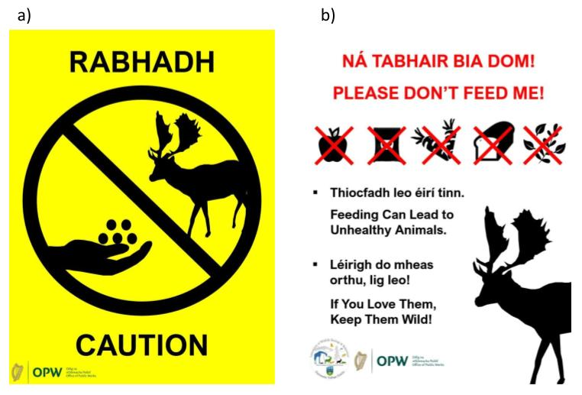

Figure 1: Final product sign released into the Phoenix Park during the campaign.

When designing management tools, such as signage, aiming to educate the public on a specific issue or rule, it is necessary to include input from individuals independent from science or the study. Remember that cultural context plays an important role in how humans respond to wildlife tourism management, and not every group is subject to the same biases as you, for example colours in signage for ‘attention’ or ‘danger’ may vary country to country. For a tool such as signage to be effective, the visual appearance is just as important for engagement as the conservation message. Open communication with individuals who have thorough training in design and the social sciences, which we as biologists may lack, is therefore not only advisable but fundamental.